**SQL Training**

### Attention

1. The <XXXX> used in this article represents the employee ID. Please replace it with your own employee ID.

### Create data object

#### Create tables and table indexes

Table ：CUX_OM_CUSTOMERS_XXXX

For storing customer information。

| Field | Type | Nullable | Default Value | Description |
| --- | --- | --- | --- | --- |
|  |  |  |  |  |
| CUSTOMER_ID | BIGINT | N |  |  |
| CUSTOMER_NUMBER | VARCHAR(30) | N |  |  |
| CUSTOMER_NAME | VARCHAR(100) | N |  |  |
| TELEPHONE | VARCAHR(50) | Y |  |  |
| START_DATE_ACTIVE | DATE | Y |  |  |
| END_DATE_ACTIVE | DATE | Y |  |  |
| CREATED_BY | BIGINT | N |  |  |
| CREATION_DATE | DATE | N |  |  |
| LAST_UPDATED_BY | BIGINT | N |  |  |
| LAST_UPDATE_DATE | DATE | N |  |  |
| LAST_UPDATE_LOGIN | BIGINT | Y |  |  |

Create indexes：

| Index | Unique | Field | Description |
| --- | --- | --- | --- |
|  |  |  |  |
| CUX_OM_CUSTOMERS_XXXX_U1 | Y | CUSTOMER_ID |  |
| CUX_OM_CUSTOMERS_XXXX_U2 | Y | CUSTOMER_NUMBER |  |
| CUX_OM_CUSTOMERS_XXXX_U3T N | Y | CUSTOMER_NAME |  |

Table：CUX_OM_ITEMS_XXXX

For storing product information。

| Field | Type | Nullable | Default Value | Description |
| --- | --- | --- | --- | --- |
|  |  |  |  |  |
| ITEM_ID | BIGINT | N |  |  |
| ITEM_NUMBER | VARCHAR(30) | N |  |  |
| ITEM_NAME | VARCHAR(100) | N |  |  |
| UOM_CODE | VARCHAR(25) | Y |  |  |
| START_DATE_ACTIVE | DATE | Y |  |  |
| END_DATE_ACTIVE | DATE | Y |  |  |
| CREATED_BY | BIGINT | N |  |  |
| CREATION_DATE | DATE | N |  |  |
| LAST_UPDATED_BY | BIGINT | N |  |  |
| LAST_UPDATE_DATE | DATE | N |  |  |
| LAST_UPDATE_LOGIN | BIGINT | Y |  |  |

Create indexes：

| Index | Unique | Field | Description |
| --- | --- | --- | --- |
|  |  |  |  |
| CUX_OM_ITEMS_XXXX_U1 | Y | ITEM_ID |  |
| CUX_OM_ITEMS_XXXX_U2 | Y | ITEM_NUMBER |  |

table：CUX_OM_HEADERS_XXXX

For storing sales order header information。

| Field | Type | Nullable | DefaultValue | Description |
| --- | --- | --- | --- | --- |
|  |  |  |  |  |
| HEADER_ID | BIGINT | N |  |  |
| ORG_ID | BIGINT | Y | 101 |  |
| ORDER_NUMBER | VARCHAR(30) | N |  |  |
| CUSTOMER_ID | BIGINT | Y |  |  |
| ORDER_DATE | DATE | N |  |  |
| ORDER_STATUS | VARCHAR(30) | Y |  | status list:  UNAPPROVED  APPROVED  CANCELLED  CLOSED |
| DESCRIPTION | VARCHAR(240) | Y |  |  |
| CREATED_BY | BIGINT | N |  |  |
| CREATION_DATE | DATE | N |  |  |
| LAST_UPDATED_BY | BIGINT | N |  |  |
| LAST_UPDATE_DATE | DATE | N |  |  |
| LAST_UPDATE_LOGIN | BIGINT | Y |  |  |
| ATTRIBUTE_CATEGORY | VARCHAR(30) | Y |  |  |
| ATTRIBUTE1 | VARCHAR(150) | Y |  |  |
| ATTRIBUTE2 | VARCHAR(150) | Y |  |  |
| ATTRIBUTE3 | VARCHAR(150) | Y |  |  |
| ATTRIBUTE4 | VARCHAR(150) | Y |  |  |
| ATTRIBUTE5 | VARCHAR(150) | Y |  |  |
| ATTRIBUTE6 | VARCHAR(150) | Y |  |  |
| ATTRIBUTE7 | VARCHAR(150) | Y |  |  |
| ATTRIBUTE8 | VARCHAR(150) | Y |  |  |
| ATTRIBUTE9 | VARCHAR(150) | Y |  |  |
| ATTRIBUTE10 | VARCHAR(150) | Y |  |  |
| ATTRIBUTE11 | VARCHAR(150) | Y |  |  |
| ATTRIBUTE12 | VARCHAR(150) | Y |  |  |
| ATTRIBUTE13 | VARCHAR(150) | Y |  |  |
| ATTRIBUTE14 | VARCHAR(150) | Y |  |  |
| ATTRIBUTE15 | VARCHAR(150) | Y |  |  |

Create Indexes：

| Index | Unique | Field | Description |
| --- | --- | --- | --- |
|  |  |  |  |
| CUX_OM_HEADERS_XXXX _U1 | Y | HEADER_ID |  |
| CUX_OM_HEADERS_XXXX _U2 | Y | ORDER_NUMBER |  |
| CUX_OM_HEADERS_XXXX _N1 |  | CUSTOMER_ID |  |

Table：CUX_OM_LINES_XXXX

For storing sales order line information。

| Field | Type | Nullable | Default Value | Description |
| --- | --- | --- | --- | --- |
|  |  |  |  |  |
| LINE_ID | BIGINT | N |  |  |
| HEADER_ID | BIGINT | N |  |  |
| LINE_NUMBER | VARCHAR(30) | N |  |  |
| ITEM_ID | BIGINT | N |  |  |
| UNIT_PRICE | DECIMAL(10,2) | Y |  |  |
| QUANTITY | DECIMAL(10,2) | Y |  |  |
| DESCRIPTION | VARCHAR(240) | Y |  |  |
| ADDITION1 | VARCHAR(150) | Y |  |  |
| ADDITION2 | VARCHAR(150) | Y |  |  |
| ADDITION3 | VARCHAR(150) | Y |  |  |
| ADDITION4 | VARCHAR(150) | Y |  |  |
| ADDITION5 | VARCHAR(150) | Y |  |  |
| CREATED_BY | BIGINT | N |  |  |
| CREATION_DATE | DATE | N |  |  |
| LAST_UPDATED_BY | BIGINT | N |  |  |
| LAST_UPDATE_DATE | DATE | N |  |  |
| LAST_UPDATE_LOGIN | BIGINT | Y |  |  |
| ATTRIBUTE_CATEGORY | VARCHAR(30) | Y |  |  |
| ATTRIBUTE1 | VARCHAR(150) | Y |  |  |
| ATTRIBUTE2 | VARCHAR(150) | Y |  |  |
| ATTRIBUTE3 | VARCHAR(150) | Y |  |  |
| ATTRIBUTE4 | VARCHAR(150) | Y |  |  |
| ATTRIBUTE5 | VARCHAR(150) | Y |  |  |
| ATTRIBUTE6 | VARCHAR(150) | Y |  |  |
| ATTRIBUTE7 | VARCHAR(150) | Y |  |  |
| ATTRIBUTE8 | VARCHAR(150) | Y |  |  |
| ATTRIBUTE9 | VARCHAR(150) | Y |  |  |
| ATTRIBUTE10 | VARCHAR(150) | Y |  |  |
| ATTRIBUTE11 | VARCHAR(150) | Y |  |  |
| ATTRIBUTE12 | VARCHAR(150) | Y |  |  |
| ATTRIBUTE13 | VARCHAR(150) | Y |  |  |
| ATTRIBUTE14 | VARCHAR(150) | Y |  |  |
| ATTRIBUTE15 | VARCHAR(150) | Y |  |  |

Create Indexes：

| Index | Unique | Field | Description |
| --- | --- | --- | --- |
|  |  |  |  |
| CUX_OM_LINES_XXXX _U1 | Y | LINE_ID |  |
| CUX_OM_LINES_XXXX _N1 |  | HEADER_ID |  |
| CUX_OM_LINES_XXXX _N2 |  | ITEM_ID |  |

#### Import data

excel：《1 – Table Data.xls》

1．CUX_OM_CUSTOMERS_XXXX

2．CUX_OM_ITEMS_XXXX

4．CUX_OM_HEADERS_XXXX

5．CUX_OM_LINES_XXXX

### Questions

#### NO.01

Please create the above objects in the database: table, table index。

#### NO.02

Please import the corresponding table data in the file: "1 – Table Data.xlsx" into the table。

#### NO.03

Create a view：CUX_OM_HEADERS_V

* view：CUX_OM_HEADERS_V

| Field | Type | Nullable | DefaultValue | Description |
| --- | --- | --- | --- | --- |
|  |  |  |  |  |
| HEADER_ID | BIGINT | N |  |  |
| ORDER_NUMBER | VARCHAR(30) | N |  |  |
| CUSTOMER_ID | BIGINT | Y |  |  |
| ORDER_DATE | DATE | N |  |  |
| ORDER_STATUS | VARCHAR(30) | Y |  | status list:  UNAPPROVED  APPROVED  CANCELLED  CLOSED |
| DESCRIPTION | VARCHAR(240) | Y |  |  |
| CREATED_BY | BIGINT | N |  |  |
| CREATION_DATE | DATE | N |  |  |
| LAST_UPDATED_BY | BIGINT | N |  |  |
| LAST_UPDATE_DATE | DATE | N |  |  |
| LAST_UPDATE_LOGIN | BIGINT | Y |  |  |
| ATTRIBUTE_CATEGORY | VARCHAR(30) | Y |  |  |
| ATTRIBUTE1 | VARCHAR(150) | Y |  |  |
| ATTRIBUTE2 | VARCHAR(150) | Y |  |  |
| ATTRIBUTE3 | VARCHAR(150) | Y |  |  |
| ATTRIBUTE4 | VARCHAR(150) | Y |  |  |
| ATTRIBUTE5 | VARCHAR(150) | Y |  |  |
| ATTRIBUTE6 | VARCHAR(150) | Y |  |  |
| ATTRIBUTE7 | VARCHAR(150) | Y |  |  |
| ATTRIBUTE8 | VARCHAR(150) | Y |  |  |
| ATTRIBUTE9 | VARCHAR(150) | Y |  |  |
| ATTRIBUTE10 | VARCHAR(150) | Y |  |  |
| ATTRIBUTE11 | VARCHAR(150) | Y |  |  |
| ATTRIBUTE12 | VARCHAR(150) | Y |  |  |
| ATTRIBUTE13 | VARCHAR(150) | Y |  |  |
| ATTRIBUTE14 | VARCHAR(150) | Y |  |  |
| ATTRIBUTE15 | VARCHAR(150) | Y |  |  |
| CUSTOMER_NUMBER | VARCHAR(30) |  |  |  |
| CUSTOMER_NAME | VARCHAR(100) |  |  |  |
| TELEPHONE | VARCHAR(50) | Y |  |  |

#### NO.04

Write SQL to display the following information and sort it by customer_number and order_number in ascending order。

|  |  |  |  |  |  |
| --- | --- | --- | --- | --- | --- |
| order_number | customer_number | customer_name | order_date | order_status | description |
|  |  |  |  |  |  |
|  |  |  |  |  |  |

#### NO.05

Write SQL to display order and order line information, sorted by order number and line number in ascending order (including orders with all statuses)

|  |  |  |  |  |  |  |
| --- | --- | --- | --- | --- | --- | --- |
| order_number | customer_name | order_date | order_status | line_number | item_number | item_name |
|  |  |  |  |  |  |  |

#### NO.06

Write SQL to display products purchased by customers

|  |  |  |  |  |
| --- | --- | --- | --- | --- |
| customer_number | customer_number | item_number | item_name | uom_code |
| 1101 | 汉得信息技术股份有限公司 | SB86662 | 办公用品 | 个 |

#### NO.07

Write SQL to count all orders (excluding canceled orders) and calculate the average sales unit price and the highest and lowest unit price by product.

|  |  |  |  |  |
| --- | --- | --- | --- | --- |
| item_number | item_name | average_unit_price | highest_unit_price | lowest_unit_price |
|  |  |  |  |  |

#### NO.08

Write SQL to query customer information about canceled orders.

|  |  |  |  |  |
| --- | --- | --- | --- | --- |
| customer_number | customer_name | telephone | start_date_active | end_date_active |
|  |  |  |  |  |

#### NO.09

Write SQL to count the company's total sales in 2015. (All orders with status CANCELLED are excluded from statistics)

|  |
| --- |
| Total Sales |
|  |

#### NO.10

Write a script to add an index to the table: CUX_OM_ITEMS_XXXX: a normal index, and the applicable field: ITEM_NAME.

Answer:

1. CREATE DATABASE IF NOT exists SQLTraining;

USE sqltraining;

CREATE TABLE CUX_OM_CUSTOMERS_46321 (

CUSTOMER_ID BIGINT primary key,

CUSTOMER_NUMBER VARCHAR(30) NOT NULL,

CUSTOMER_NAME VARCHAR(100) NOT NULL,

TELEPHONE VARCHAR(50) ,

START_DATE_ACTIVE DATE ,

END_DATE_ACTIVE DATE,

CREATED_BY BIGINT NOT NULL,

CREATION_DATE date NOT NULL,

LAST_UPDATED_BY BIGINT NOT NULL,

LAST_UPDATE_DATE DATE NOT NULL,

LAST_UPDATE_LOGIN BIGINT

);

CREATE UNIQUE INDEX CUX_OM_CUSTOMERS_46321_U2

ON CUX_OM_CUSTOMERS_46321 (CUSTOMER_NUMBER);

CREATE UNIQUE INDEX CUX_OM_CUSTOMERS_46321_U3TN

ON CUX_OM_CUSTOMERS_46321 (CUSTOMER_NAME);

CREATE TABLE CUX_OM_ITEMS_46321 (

ITEM_ID BIGINT primary key,

ITEM_NUMBER VARCHAR(30) NOT NULL,

ITEM_NAME VARCHAR(100) NOT NULL,

UOM_CODE VARCHAR(25) ,

START_DATE_ACTIVE DATE ,

END_DATE_ACTIVE DATE,

CREATED_BY BIGINT NOT NULL,

CREATION_DATE date NOT NULL,

LAST_UPDATED_BY BIGINT NOT NULL,

LAST_UPDATE_DATE DATE NOT NULL,

LAST_UPDATE_LOGIN BIGINT

);

CREATE UNIQUE INDEX CUX_OM_ITEMS__46321_U2

ON CUX_OM_ITEMS_46321 (ITEM_NUMBER);

CREATE TABLE CUX_OM_HEADERS_46321(

HEADER_ID BIGINT PRIMARY KEY,

ORG_ID BIGINT DEFAULT 101,

ORDER_NUMBER VARCHAR(30) NOT NULL,

CUSTOMER_ID BIGINT,

ORDER_DATE DATE NOT NULL,

ORDER_STATUS VARCHAR(30),

`DESCRIPTION` VARCHAR(240),

CREATED_BY BIGINT NOT NULL,

CREATION_DATE DATE NOT NULL,

LAST_UPDATED_BY BIGINT NOT NULL,

LAST_UPDATE_DATE DATE NOT NULL,

LAST_UPDATE_LOGIN BIGINT,

ATTRIBUTE_CATEGORY VARCHAR(30),

ATTRIBUTE1 VARCHAR(150),

ATTRIBUTE2 VARCHAR(150),

ATTRIBUTE3 VARCHAR(150),

ATTRIBUTE4 VARCHAR(150),

ATTRIBUTE5 VARCHAR(150),

ATTRIBUTE6 VARCHAR(150),

ATTRIBUTE7 VARCHAR(150),

ATTRIBUTE8 VARCHAR(150),

ATTRIBUTE9 VARCHAR(150),

ATTRIBUTE10 VARCHAR(150),

ATTRIBUTE11 VARCHAR(150),

ATTRIBUTE12 VARCHAR(150),

ATTRIBUTE13 VARCHAR(150),

ATTRIBUTE14 VARCHAR(150),

ATTRIBUTE15 VARCHAR(150)

);

CREATE UNIQUE INDEX CUX_OM_HEADERS__46321_U2

ON CUX_OM_HEADERS_46321 (ORDER_NUMBER);

CREATE TABLE CUX_OM_LINES_46321(

LINE_ID BIGINT PRIMARY KEY,

HEADER_ID BIGINT NOT NULL,

LINE_NUMBER VARCHAR(30) NOT NULL,

ITEM_ID BIGINT NOT NULL,

UNIT_PRICE DECIMAL(10,2),

QUANTITY DECIMAL(10,2),

`DESCRIPTION` VARCHAR(240),

ADDITION1 VARCHAR(150),

ADDITION2 VARCHAR(150),

ADDITION3 VARCHAR(150),

ADDITION4 VARCHAR(150),

ADDITION5 VARCHAR(150),

CREATED_BY BIGINT NOT NULL,

CREATION_DATE DATE NOT NULL,

LAST_UPDATED_BY BIGINT NOT NULL,

LAST_UPDATE_DATE DATE NOT NULL,

LAST_UPDATE_LOGIN BIGINT,

ATTRIBUTE_CATEGORY VARCHAR(30),

ATTRIBUTE1 VARCHAR(150),

ATTRIBUTE2 VARCHAR(150),

ATTRIBUTE3 VARCHAR(150),

ATTRIBUTE4 VARCHAR(150),

ATTRIBUTE5 VARCHAR(150),

ATTRIBUTE6 VARCHAR(150),

ATTRIBUTE7 VARCHAR(150),

ATTRIBUTE8 VARCHAR(150),

ATTRIBUTE9 VARCHAR(150),

ATTRIBUTE10 VARCHAR(150),

ATTRIBUTE11 VARCHAR(150),

ATTRIBUTE12 VARCHAR(150),

ATTRIBUTE13 VARCHAR(150),

ATTRIBUTE14 VARCHAR(150),

ATTRIBUTE15 VARCHAR(150)

);

1. Imported Data Below

1. Answer for Create View

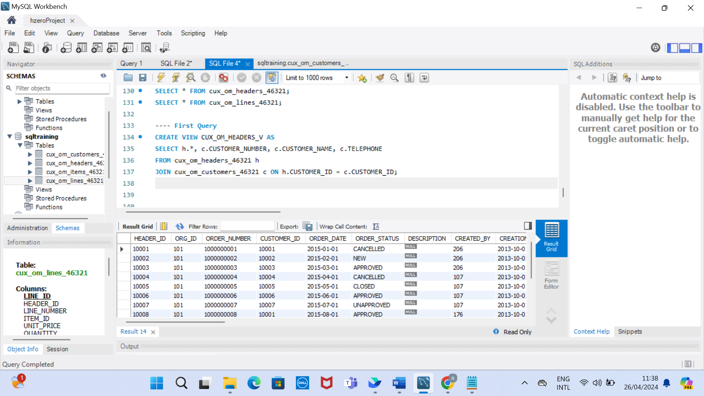

1. Answer

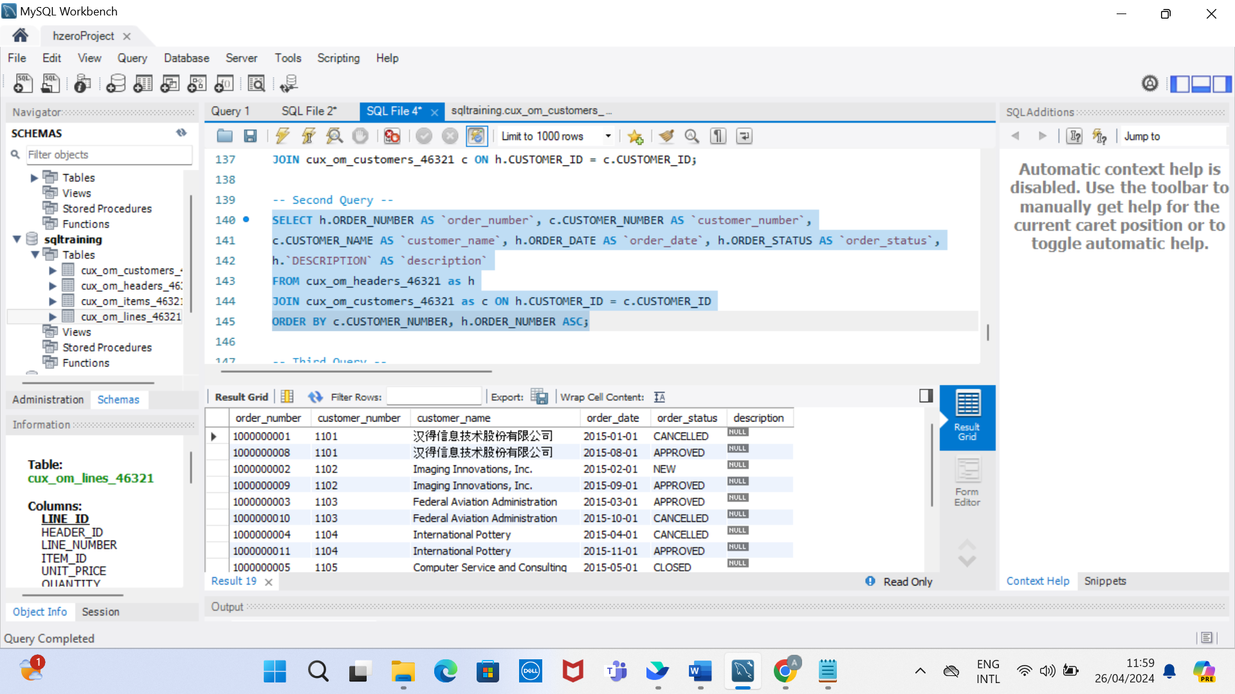

1. Answer

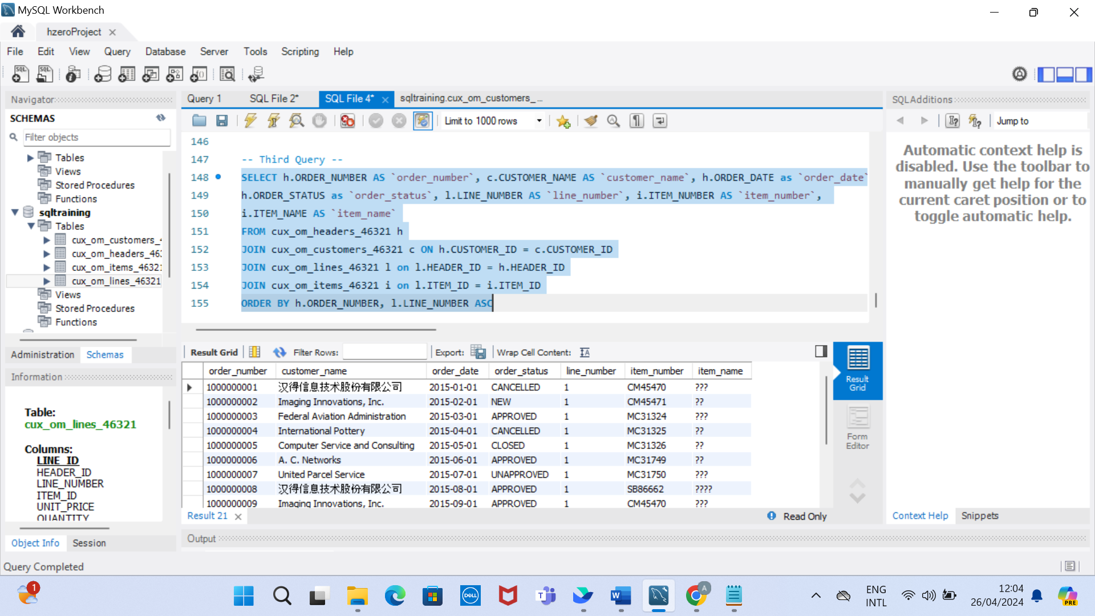

1. Answer

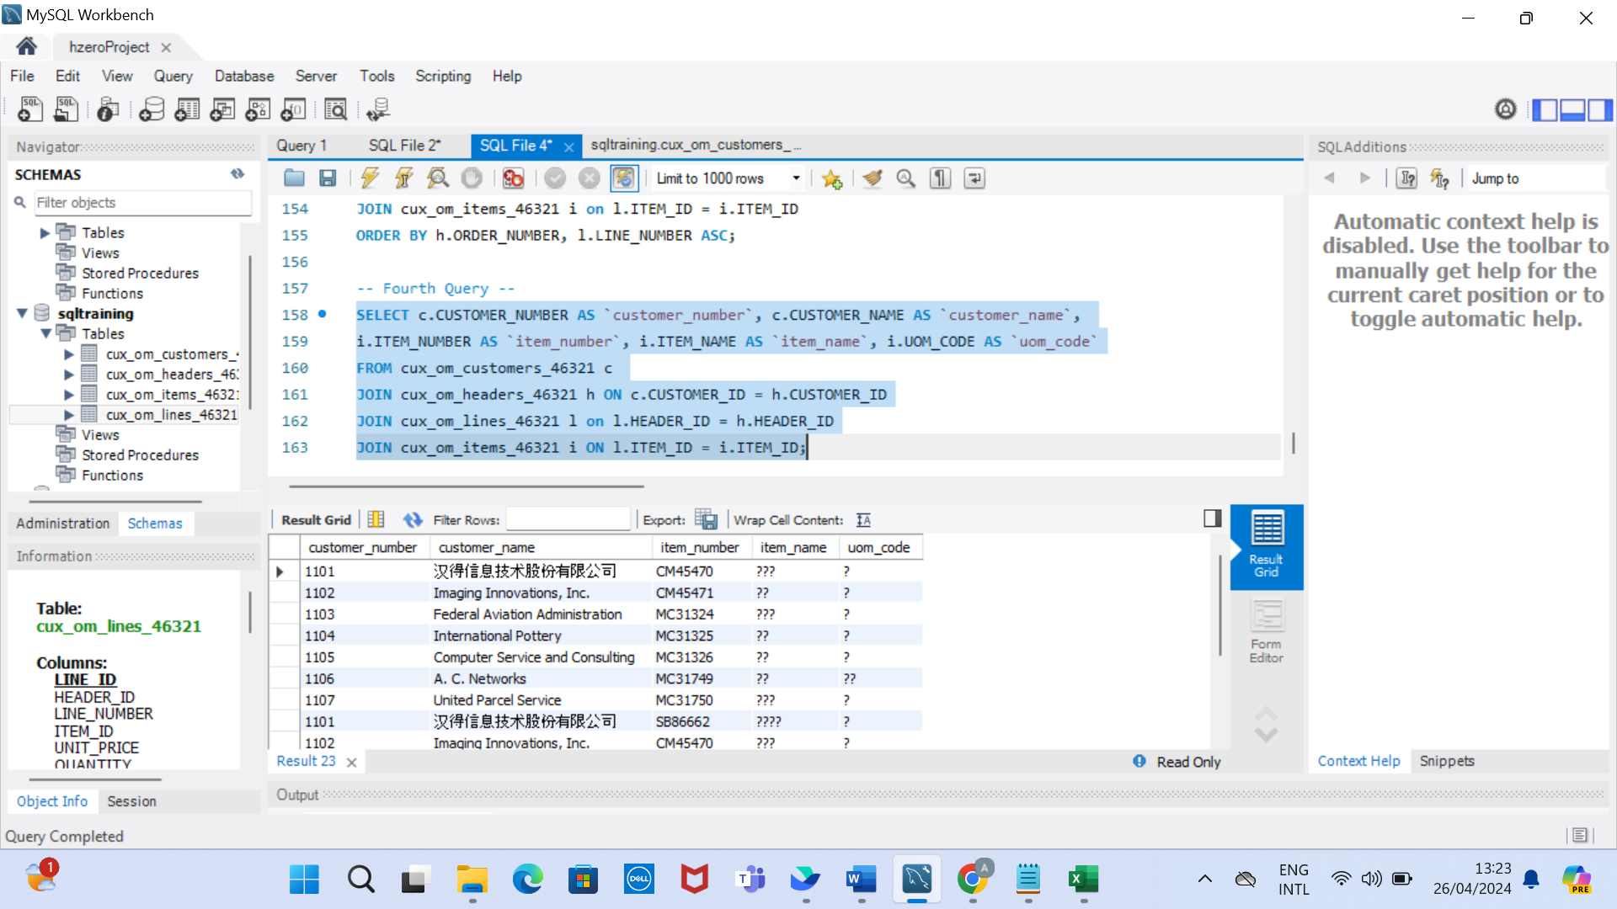

1. Answer:

1. Answer:

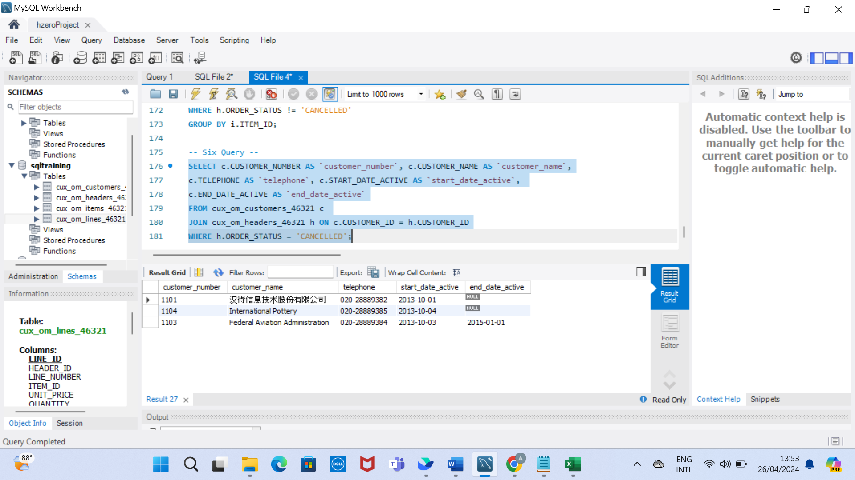

1. Answer:

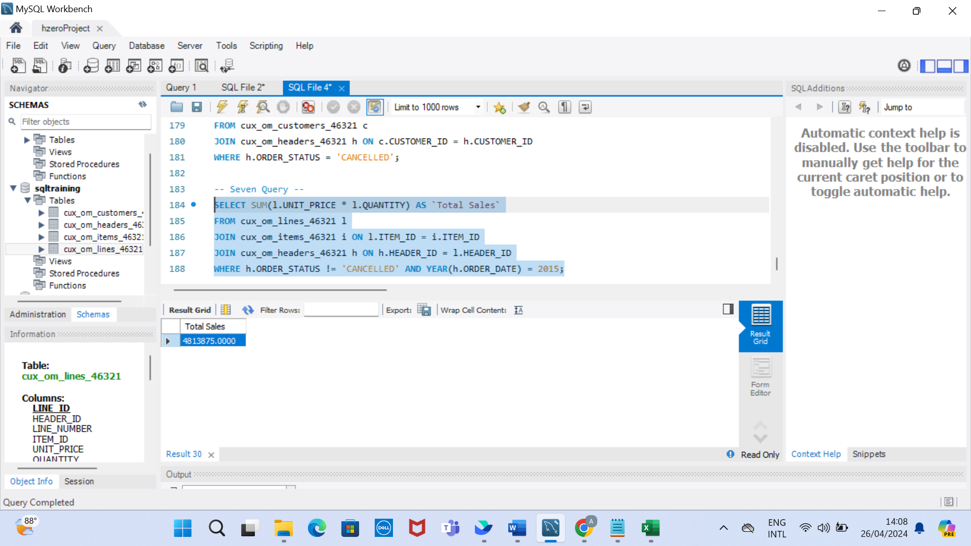

1. Answer:

